Table 1
EFA Results
Item | SA | PTEO | TSR | TC | EMP | TDQ | TCR | h²
TDQ1 |  |  |  |  |  | 0.822 |  | 0.670
TDQ2 |  |  |  |  |  | 0.807 |  | 0.668
TDQ3 |  |  |  |  |  | 0.789 |  | 0.611
TDQ4 |  |  |  |  |  | 0.811 |  | 0.665
TC1 |  |  |  | 0.836 |  |  |  | 0.696
TC2 |  |  |  | 0.806 |  |  |  | 0.631
TC3 |  |  |  | 0.814 |  |  |  | 0.683
TC4 |  |  |  | 0.797 |  |  |  | 0.650
TCR1 |  |  |  |  |  |  | 0.844 | 0.712
TCR2 |  |  |  |  |  |  | 0.794 | 0.640
TCR3 |  |  |  |  |  |  | 0.795 | 0.655
TCR4 |  |  |  |  |  |  | 0.793 | 0.611
TSR1 |  |  | 0.808 |  |  |  |  | 0.658
TSR2 |  |  | 0.832 |  |  |  |  | 0.700
TSR3 |  |  | 0.805 |  |  |  |  | 0.643
TSR4 |  |  | 0.817 |  |  |  |  | 0.669
SA1 | 0.843 |  |  |  |  |  |  | 0.710
SA2 | 0.799 |  |  |  |  |  |  | 0.669
SA3 | 0.843 |  |  |  |  |  |  | 0.700
SA4 | 0.855 |  |  |  |  |  |  | 0.734
EMP1 |  |  |  |  | 0.807 |  |  | 0.657
EMP2 |  |  |  |  | 0.828 |  |  | 0.695
EMP3 |  |  |  |  | 0.812 |  |  | 0.661
EMP4 |  |  |  |  | 0.811 |  |  | 0.661
PTEO1 |  | 0.836 |  |  |  |  |  | 0.697
PTEO2 |  | 0.800 |  |  |  |  |  | 0.660
PTEO3 |  | 0.826 |  |  |  |  |  | 0.700
PTEO4 |  | 0.829 |  |  |  |  |  | 0.672
Eigenvalue | 7.83 | 2.40 | 2.15 | 1.80 | 1.77 | 1.54 | 1.29
Variance | 27.98% | 8.56% | 7.68% | 6.42% | 6.32% | 5.49% | 4.62% | 67.06%*
Sampling Adequacy |  |  |  | KMO = 0.910
Bartlett's Test of Sphericity |  |  |  | χ²(378) = 25169.79, p < .001.
Note. N = 1500. Extraction: Principal Axis Factoring (PAF). Rotation: Promax with Kaiser normalization. Only primary factor loadings ≥ 0.5 are presented. h²: communality. *Total variance explained (cumulative).

Figure 1
Scree Plot
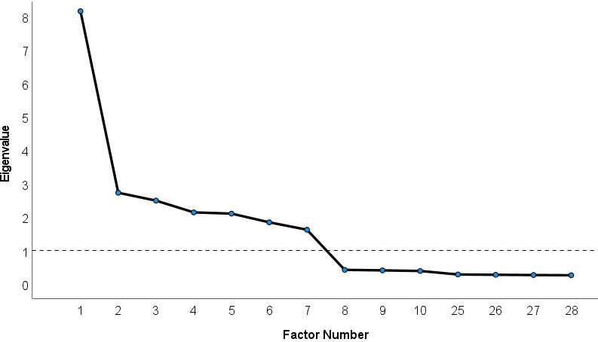

Measurement Model

Table 2
Reliability and Validity of the Measurement Model
Variable | CA | CR | AVE | HTMT
 |  |  |  | EMP | PTEO | SA | TC | TCR | TDQ | TSR
EMP | 0.889 | 0.923 | 0.750
PTEO | 0.895 | 0.927 | 0.760 | 0.501
SA | 0.904 | 0.933 | 0.776 | 0.448 | 0.406
TC | 0.887 | 0.922 | 0.747 | 0.294 | 0.251 | 0.319
TCR | 0.882 | 0.919 | 0.739 | 0.326 | 0.250 | 0.377 | 0.291
TDQ | 0.882 | 0.918 | 0.738 | 0.262 | 0.271 | 0.347 | 0.238 | 0.313
TSR | 0.888 | 0.923 | 0.749 | 0.263 | 0.274 | 0.349 | 0.345 | 0.288 | 0.225

Figure 2
Measurement Model

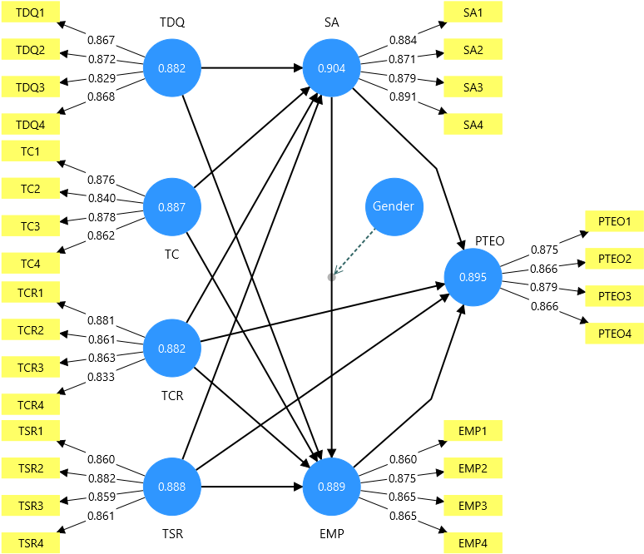

Structural Model

Table 3
Direct Effects and Moderation Results
Path | Estimate | T statistics | P values | F² | Result
Controls
Age → PTEO | -0.005 | 0.239 | 0.811 | 0.000 | Not Supported
Education → PTEO | 0.003 | 0.112 | 0.911 | 0.000 | Not Supported
Experience → PTEO | 0.027 | 1.197 | 0.231 | 0.002 | Not Supported
PMKVY → PTEO | 0.019 | 0.825 | 0.409 | 0.001 | Not Supported
Direct Effects
TDQ → SA | 0.189 | 8.210 | 0.000 | 0.041 | H1: Supported
TC → SA | 0.139 | 5.594 | 0.000 | 0.021 | H2: Supported
TCR → SA | 0.202 | 8.185 | 0.000 | 0.045 | H3: Supported
TSR → SA | 0.181 | 7.398 | 0.000 | 0.036 | H4: Supported
SA → EMP | 0.149 | 3.090 | 0.002 | 0.007 | H5: Supported
EMP → PTEO | 0.337 | 14.083 | 0.000 | 0.123 | H6: Supported
TCR → PTEO | 0.038 | 1.566 | 0.117 | 0.002 | H7: Not Supported
TSR → PTEO | 0.097 | 4.079 | 0.000 | 0.011 | H8: Supported
Moderation Effect
Gender x SA → EMP | 0.150 | 2.812 | 0.005 | 0.006 | H15: Supported
Note. F² > 0.02 = Small.

Table 4
Mediation Results
Path | Estimate | LB | UB | T | P | Result
Simple Mediation
TDQ → SA → EMP | 0.028 | 0.010 | 0.048 | 2.873 | 0.004 | H10: Supported*
TC → SA → EMP | 0.021 | 0.007 | 0.038 | 2.533 | 0.011 | H11: Supported*
TCR → SA → EMP | 0.030 | 0.011 | 0.052 | 2.936 | 0.003 | H12: Supported*
TSR → SA → EMP | 0.027 | 0.010 | 0.048 | 2.790 | 0.005 | H13: Supported**
Sequential Mediation
TDQ → SA → EMP → PTEO | 0.009 | 0.003 | 0.016 | 2.851 | 0.004 | H14: Supported*
Note. LB = 95% confidence lower bound. UB = upper bound. *Complementary / Partial mediation as direct effects in Table 3 are significant.

Table S1
Direct Effects for Mediation Classification
Path | Estimate | T statistics | P values | F2 | Result
SA → PTEO | 0.187 | 7.152 | 0.000 | 0.035 | Supported
TC → EMP | 0.106 | 4.367 | 0.000 | 0.013 | Supported
TCR → EMP | 0.113 | 4.556 | 0.000 | 0.014 | Supported
TDQ → EMP | 0.069 | 2.859 | 0.004 | 0.006 | Supported
TSR → EMP | 0.048 | 1.953 | 0.051 | 0.003 | Not Supported

Table 5
Quality Features of the Structural Model
Outcome Variable | R² | VIF | Q² Predict | CVPAT ΔLoss | t | p
EMP | 0.265 | 4.167 | 0.066 | -0.080 | 2.446 | 0.015
PTEO | 0.252 | 1.329 | 0.110 | -0.135 | 6.394 | 0.000
SA | 0.224 | 1.166 | 0.219 | -0.281 | 10.282 | 0.000
Note. Negative values of CVPAT ΔLoss indicate that the PLS-SEM model has a lower prediction error compared to the Indicator Average model.

Table S2
VIF for Common Method Bias (CMB)
Predictor Variable | PTEO | EMP | SA
EMP | 1.244
Gender |  | 1.071
SA | 1.329 | 4.167
TC |  | 1.191 | 1.164
TCR | 1.192 | 1.223 | 1.166
TDQ |  | 1.167 | 1.120
TSR | 1.152 | 1.206 | 1.159

Figure 3
Structural Model
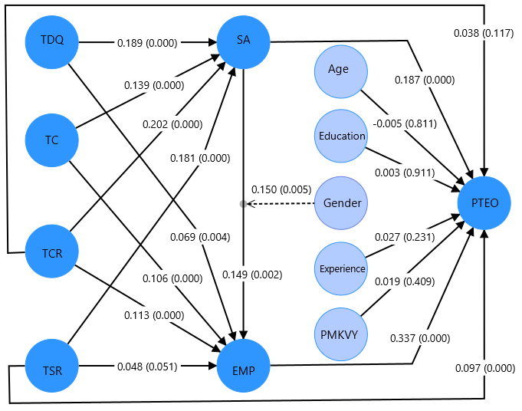

Figure 4
Simple Slopes – H15
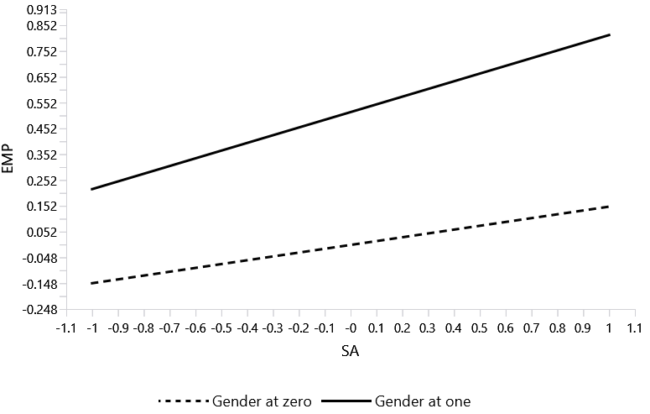
ANN

Table 6
Root Mean Square Error (RMSE) by Neural Network Model
ANN | Training |  |  | Testing |  |  | N
ANN | SSE | RMSE | n | SSE | RMSE | n | N
NN1 | 386.97 | 0.608 | 1046 | 155.78 | 0.586 | 454 | 1500
NN2 | 396.94 | 0.614 | 1053 | 156.29 | 0.591 | 447 | 1500
NN3 | 386.19 | 0.611 | 1033 | 176.33 | 0.614 | 467 | 1500
NN4 | 402.45 | 0.614 | 1066 | 159.11 | 0.605 | 434 | 1500
NN5 | 386.24 | 0.605 | 1055 | 165.98 | 0.611 | 445 | 1500
NN6 | 387.93 | 0.604 | 1062 | 177.04 | 0.636 | 438 | 1500
NN7 | 391.67 | 0.608 | 1061 | 166.10 | 0.615 | 439 | 1500
NN8 | 376.56 | 0.600 | 1045 | 166.87 | 0.606 | 455 | 1500
NN9 | 397.47 | 0.610 | 1067 | 154.29 | 0.597 | 433 | 1500
NN10 | 412.90 | 0.622 | 1067 | 152.92 | 0.594 | 433 | 1500
Mean | 392.53 | 0.610 | 1056 | 163.07 | 0.606 | 444 | 1500
SD | 10.25 | 0.006 |  | 8.805 | 0.015
Note. SSE = sum of squared errors. RMSE = root mean square error; n = sample size.

Figure 5
Training and Testing RMSE Across Neural Network Runs
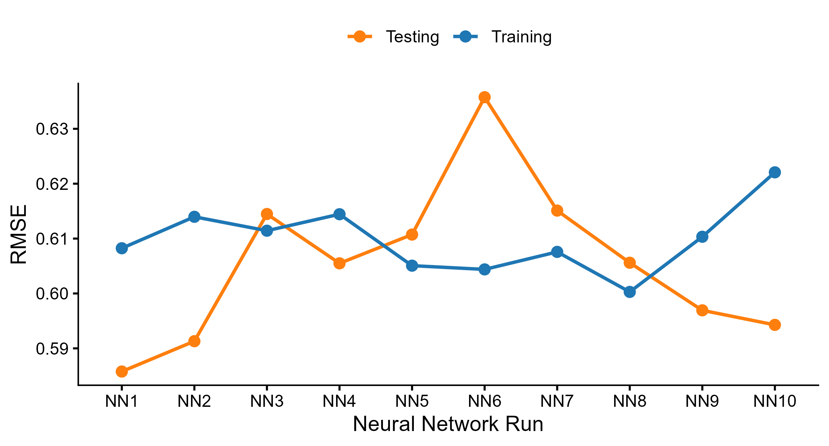

Table 7
Independent Variable Importance by Neural Network Model
ANN | TDQ | TC | TCR | TSR | SA | EMP
NN1 | 0.143 | 0.058 | 0.072 | 0.107 | 0.228 | 0.393
NN2 | 0.078 | 0.054 | 0.025 | 0.177 | 0.238 | 0.428
NN3 | 0.133 | 0.080 | 0.039 | 0.127 | 0.139 | 0.483
NN4 | 0.118 | 0.115 | 0.040 | 0.127 | 0.148 | 0.453
NN5 | 0.116 | 0.061 | 0.038 | 0.118 | 0.261 | 0.406
NN6 | 0.143 | 0.033 | 0.032 | 0.136 | 0.189 | 0.468
NN7 | 0.117 | 0.021 | 0.040 | 0.145 | 0.244 | 0.433
NN8 | 0.172 | 0.036 | 0.052 | 0.107 | 0.214 | 0.418
NN9 | 0.077 | 0.066 | 0.036 | 0.123 | 0.242 | 0.456
NN10 | 0.110 | 0.053 | 0.098 | 0.120 | 0.191 | 0.427
Average Importance | 0.121 | 0.058 | 0.047 | 0.129 | 0.209 | 0.437
Normalized Importance | 27.6% | 13.2% | 10.8% | 29.5% | 48.0% | 100.0%
Rank | 4 | 5 | 6 | 3 | 2 | 1

Figure 6
Relative Importance of Predictor Variables Across Neural Network Runs
